
Additional Residential Addresses
(Disponible en français)

Complete this form if the residential complex covered by an Application for a Rent Increase Above the Guideline (Form L5) includes multiple addresses.

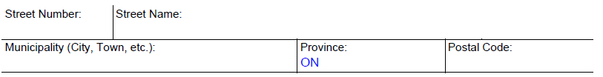

The Landlord and Tenant Board has the right to collect the information requested on this form to resolve your application under section 185 of the Residential Tenancies Act, 2006. After you file the form, all information related to the proceeding may become publicly available in a tribunal decision, order or other document, in accordance with Tribunals Ontario’s Access to Records Policy and the Tribunal Adjudicative Records Act, 2019. Parties wanting records or information to remain confidential must seek a confidentiality order from the adjudicator. If you have questions about confidentiality order or access to records, please contact us by email at LTB@ontario.ca or our Contact Center at 416-645-8080 or 1-888-332-3234 (toll free).
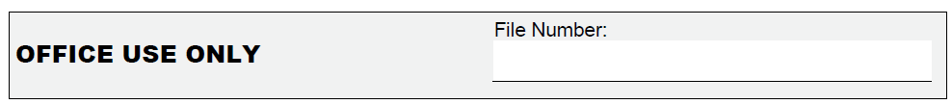

v. 11/01/2025
P age _ of _

